TASK 02 DATA CLEANING AND EDA

- GENDER DISTRIBUTION

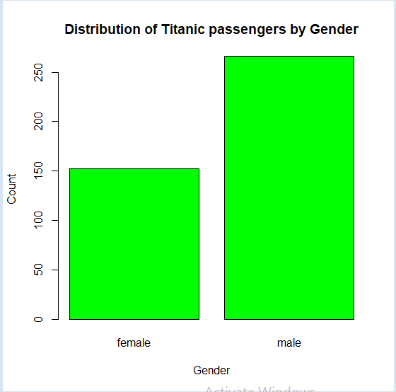
2.)PASSENGER CLASS DISTRIBUTION

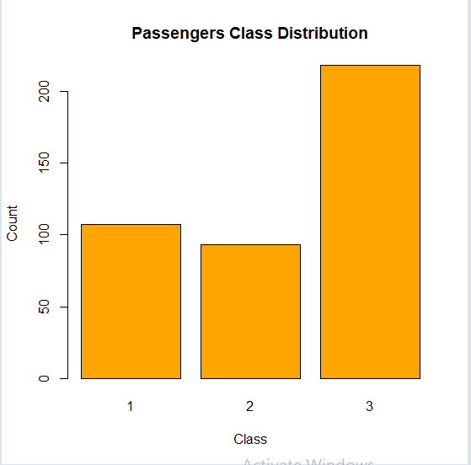

3) AGE DISTRIBUTION

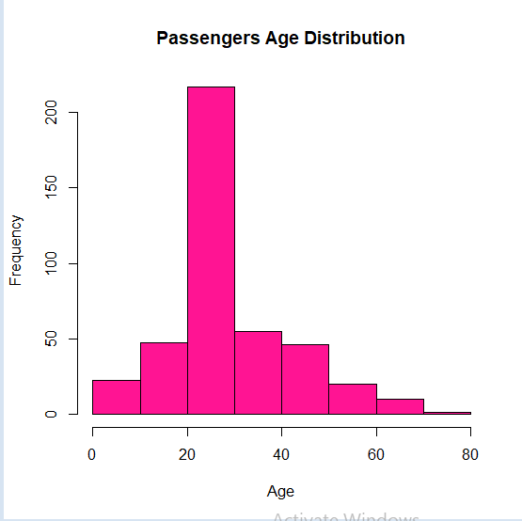

4) FARE DISTRIBUTION

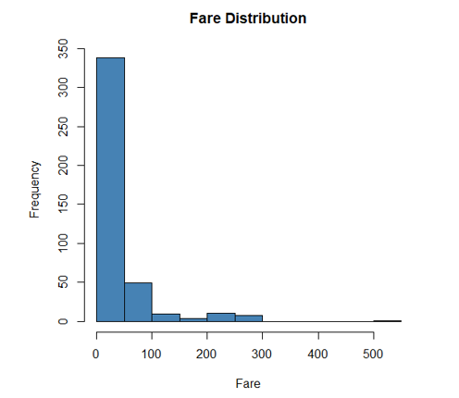

5) RELATIONSHIP BETWEEN AGE AND FARE

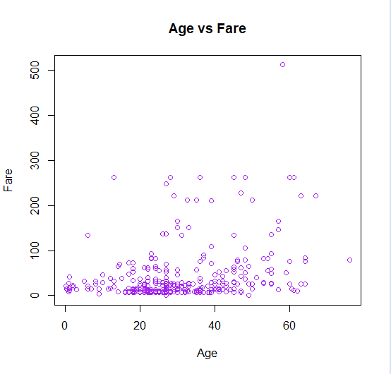
6) MALE VS FEMALE
